OT7 Divided Kingdom: 1 Kings 12-2 Kings
Dr. Marvin J. Effa
Author: A number of authors have been suggested as the compiler of Kings: Jeremiah, Ezra, or Ezekiel.
Date of writing: Since the author is unconfirmed, the date is as well.
Purpose: To trace the history of the kings of Judah and Israel from the end of David’s life to the Babylonian captivity. 1 and 2 Kings were originally a single book, but the books were divided to make them easier to use. The history is selective and demonstrates for a captive people the need to walk with the Lord.
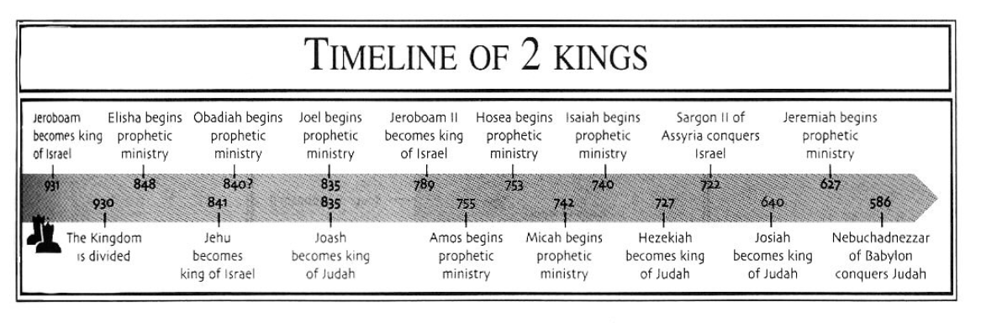
Idea: Division and destruction follow disobedience.

Development:
1 Kings, The United Kingdom (Reign of Solomon) 1:1-11:43.
1 Kings, The Divided Kingdom (Reign of Kings) 12:1-22:53.
- The Rupture in the Kingdom, 1 Kings 12:1–24
- The Reign of Jeroboam in Israel (931–910), 1 Kings 12:25–14:20
- The Reign of Rehoboam in Judah (931–913; 2 Chron. 10:1–12:16), 1 Kings 14:21–31
- The Reign of Abijam (Abijah) in Judah (913–911; 2 Chron. 13:1–22), 1 Kings 15:1–8
- The Reign of Asa in Judah (911–870; 2 Chron. 14:1–16:14), 1 Kings 15:9–24
- The Reign of Nadab in Israel (910–909), 1 Kings 15:25–31
- The Reign of Baasha in Israel (909–886), 1 Kings 15:32–16:7
- The Reign of Elah in Israel (886–885), 1 Kings 16:8–14
- The Reign of Zimri in Israel (885), 1 Kings 16:15–20
- The Reign of Omri in Israel (885–874), 1 Kings 16:21–28
- The Reign of Ahab in Israel (874–853), 1 Kings 16:29–22:40
- The Reign of Jehoshaphat in Judah (873–848; 2 Chron. 17:1–20:37), 1 Kings 22:41–50
- The Reign of Ahaziah in Israel (853), 1 Kings 22:51–53

2 Kings, The Destruction of the Northern Kingdom 1:1-17:41
- The Reign of Ahaziah in Israel (853–852), 2 Kings 1:1–18
- The Reign of Jehoram (Joram) in Israel (852–841), 2 Kings 2:1–8:15
- The Reign of Joram (Jehoram) in Judah (848–841; 2 Chron. 21:1–20), 2 Kings 8:16–24
- The Reign of Ahaziah in Judah (841; 2 Chron. 22:1–9), 2 Kings 8:25–29
- The Reign of Jehu in Israel (841–814), 2 Kings 9:1–10:36
- The Reign of Athaliah in Judah (841–835; 2 Chron. 22:10–23:15), 2 Kings 11:1–16
- The Reign of Jehoash (Joash) in Judah (835–796; 2 Chron. 23:16–24:27), 2 Kings 11:17–12:21
- The Reign of Jehoahaz in Israel (814–798), 2 Kings 13:1–9
- The Reign of Jehoash (Joash) in Israel (798–782), 2 Kings 13:10–25
- The Reign of Amaziah in Judah (796–767; 2 Chron. 25:1–28), 2 Kings 14:1–22
- The Reign of Jeroboam II in Israel (794–753), 2 Kings 14:23–29
- The Reign of Azariah (Uzziah) in Judah (790–739; 2 Chron. 26:1–23), 2 Kings 15:1–7
- The Reign of Zechariah in Israel (753), 2 Kings 15:8–12
- The Reign of Shallum in Israel (752), 2 Kings 15:13–15
- The Reign of Menahem in Israel (752–742), 2 Kings 15:16–22
- The Reign of Pekahiah in Israel (742–740), 2 Kings 15:23–26
- The Reign of Pekah in Israel (752–732), 2 Kings 15:27–31
- The Reign of Jotham in Judah (750–731; 2 Chron. 27:1–9), 2 Kings 15:32–38
- The Reign of Ahaz in Judah (731–715; 2 Chron. 28:1–27), 2 Kings 16:1–20
- The Reign of Hoshea in Israel (732–722), 2 Kings 17:1–41
II. The Surviving Kingdom of Judah, 18:1–25:30
- The Reign of Hezekiah (715–686; 2 Chron. 29:1–32:33), 2 Kings 18:1–20:21
- The Reign of Manasseh (695–642; 2 Chron. 33:1–20), 2 Kings 21:1–18
- The Reign of Amon (642–640; 2 Chron. 33:21–25), 2 Kings 21:19–26
- The Reign of Josiah (640–609; 2 Chron. 34:1–35:27), 2 Kings 22:1–23:30
- The Reign of Jehoahaz (609; 2 Chron. 36:1–4), 2 Kings 23:31–33
- The Reign of Jehoiakim (Eliakim; 609–597; 2 Chron. 36:5–8), 2 Kings 23:34–24:7
- The Reign of Jehoiachin (597; 2 Chron. 36:9–10), 2 Kings 24:8–16
- The Reign of Zedekiah (Mattaniah; 597–586; 2 Chron. 36:11–21), 2 Kings 24:17–25:21
- Gedaliah, the Puppet Governor (586), 2 Kings 25:22–26
- The Release of Jehoiachin in Babylon, 2 Kings 25:27–30

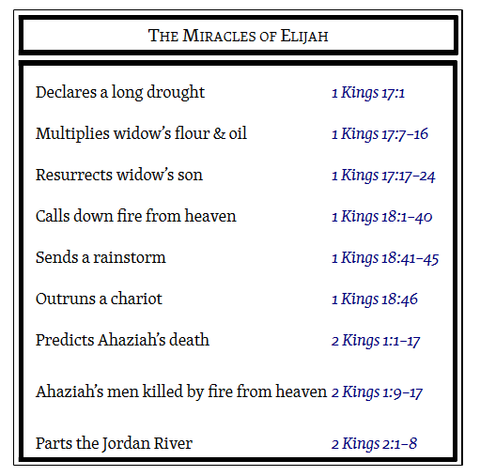 | 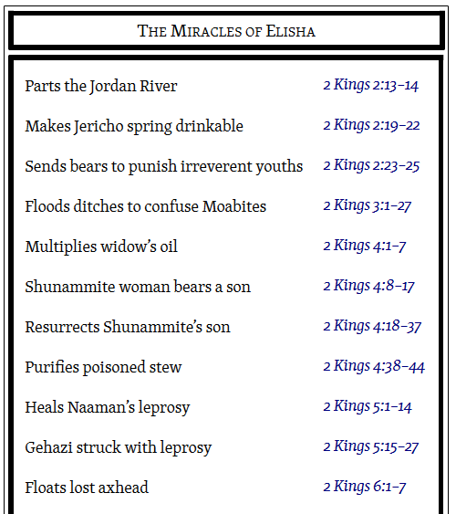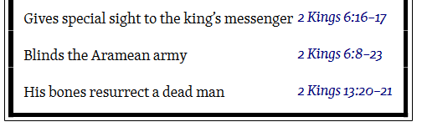

Key Passage Exegesis
- A fully developed cult, 1 Kings 12.
- Corrupt clergy, 1 Kings 13.
- Zimri’s seven day reign, 1 Kings 16.
- Ahab and Jezebel’s reign of evil, 1 Kings 17-22.
- The lying spirit, 1 Kings 22:21-23.
- God is able to protect His own people (fire from heaven), 2 Kings 1.
- Shunammite’s son’s resuscitation, 2 Kings 4.
- Naaman’s conversion, 2 Kings 5 (note verse 28-19).
- God’s unseen armies, 2 Kings 6:17.
- Jehu’s political, not spiritual, coup d'état, 2 Kings 9-10.
- Jeroboam II is hardly mentioned, 2 Kings 14:23–29.
- The destruction of Israel and the resettling of Israel, 2 Kings 17.
- Hezekiah’s deliverance from Assyria, 2 Kings 19.
- Good king Josiah, 2 Kings 22-23.
- A change in Babylonian policy, 2 Kings 15:27-30.

